Assignment 3
Bug Fix
Bug 1
for (let i = 0; i <= customers.length; i++) {
console.log(customers[i].name);
}
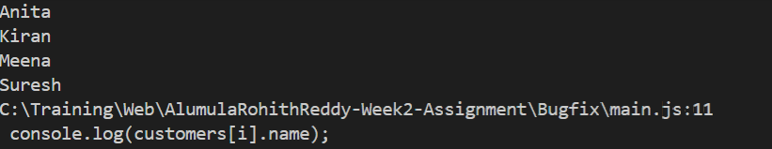
Bug is index exceeding array index values, (i <customers.length) correct one.
After Fixing
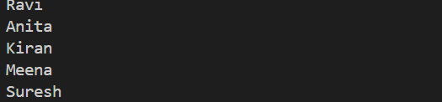

Bug 2
const activeCustomers = customers.filter((c) => {
c.active === true;
});
console.log(activeCustomers)
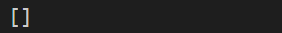
Bug is return keyword missing
After fixing
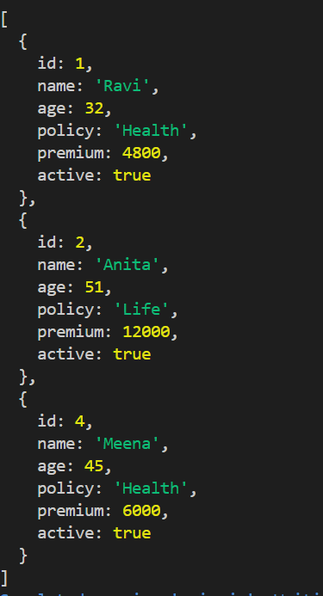

Bug 3
const updatedPremiums = customers.map((c) => {
if (c.age >= 50) {
c.premium = c.premium * 1.1;
}
});
console.log(updatedPremiums)
Bug is return the object.
After Fixing
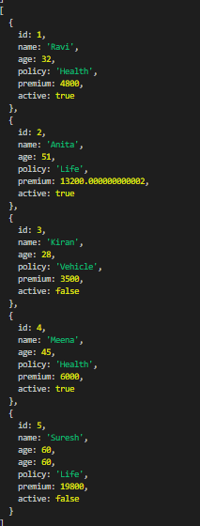
Bug 4
const totalPremium = customers.reduce((total, c) => {
total + c.premium;
}, 0);
console.log(totalPremium)
Bug is return keyword missing
After Fixing
Bug 5
console.log("Customer ${customers[0].name} has policy ${customers[0].policy}");
Bug is wrong quotes used.
After Fixing
Bug 6
const policyCount = customers.reduce((count, c) => {
count.policy = (count.policy || 0) + 1;
return count;
}, {});
console.log(policyCount)
Bug is incorrect assignment of values in object count.
After Fixing
Bug 7
const customersWithRisk = customers.map((c) => {
let riskLevel;
if (c.age < 35) riskLevel = "Low";
else if (c.age <= 50) riskLevel = "Medium";
else riskLevel = "High";
return { ...c, riskLevel };
});
console.log(customersWithRisk)
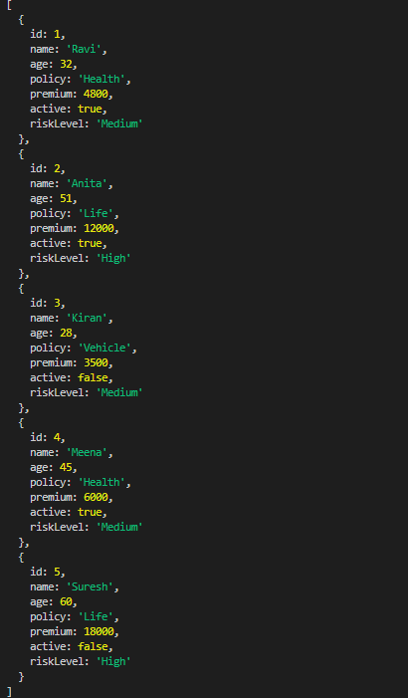
Bug is else if condition missed
After Fixing
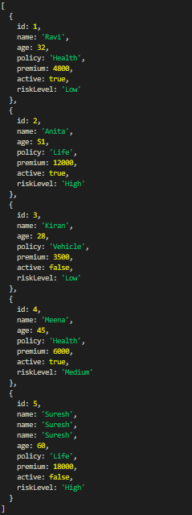
Bug 8
let active = 0,inactive = 0;
for (const c in customers) {
if (c.active) active++;
else inactive++;
}
console.log(active,inactive)
Bug is use of for..in instead of for..of
After Fixing
Bug 9
const getLifeCustomers = () =>
customers.filter((c) => c.policy === "Life").map((c) =>
c.name);
console.log(getLifeCustomers())
Bug is return keyword needed if {} brackets are used.
After Fixing
const getLifeCustomers = () =>{
return customers.filter((c) => c.policy === "Life").map((c) =>
c.name); }
console.log(getLifeCustomers())

Bug 10
const sortedCustomers = customers.sort((a, b) => b.premium - a.premium);
console.log(customers)
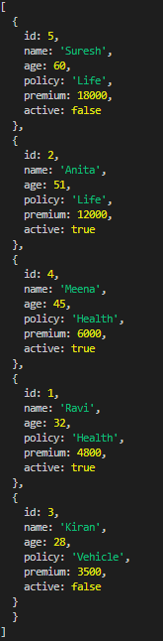
Bug is that the original array order will also change when we perform sort on it so make a copy and sort
After Fixing
